Problem Solving with Computational Thinking

1. Week 1 – Concept of Computational thinking
   1. Quiz

1/ In computational thinking terms, breaking down a complex problem into smaller, more specific, sub-problems is called decomposition.

=> Decomposition is divide and conquer a complex problem into smaller and easily solvable sub-problems.

2/ Computational thinking can help programmers conceptualize problems before they begin programming True.

=> Computational thinking is to make a brief and clear plan before solving a big problem. It helps programmers to stay focus on each step of the plan and avoid making big wrong direction.

3/ In computational thinking terms, framing a problem and determining if it can be solved by computers is known as Problem Identification.

=> Problem identification helps programmers if a problem is solvable by computer and framing the whole big project.

4/ While writing a program for building a cake, you decide that some information is less relevant for your particular program. For instance, you might decide that you **don’t** need to know the flavor of ice cream that the cake is being served with, and you **don’t** need to know what color plates the cake is being served on. In computational thinking terms, this process of ignoring or filtering out less relevant information is known as Abstraction.

=> Abstraction gets rid of irrelevant and not important information for us to solve the main problem.

5/ When identifying a problem for a computer to solve, it is best to identify problems that are subjective or open-ended. True.

=> Because computers are best of computing number and storing objects (variables)

6/ Computational thinking is a linear process. False

=> We can use computational flexible and iterative to make the best approach to solve problems

1. Week 2 – Case-study Airport Surveillance

Summary case-study: Solving complex problems in airport security and surveillance by extracting video camera

1/ Identifying suspicious behavior at an airport is a complex problem. In this case study, what was one strategy for decomposing this problem into a smaller, more manageable problem? Define a specific type of suspicious behavior in quantifiable terms.

=> We should break down this complex case-study into sub-problems.

2/ When designing an algorithm that will detect unattended luggage, what kind of information would likely **NOT** be relevant to this problem? The types of clothing people in an airport are wearing.

=> In this sub-problem, luggage is an object that we should focus on. Therefore, clothes that people are wearing are irrelevant.

3/Using the following algorithm, what would happen if the luggage in one video frame is not seen in the next frame? No warning is given, and the algorithm checks if there are more objects to categorize in the frame.

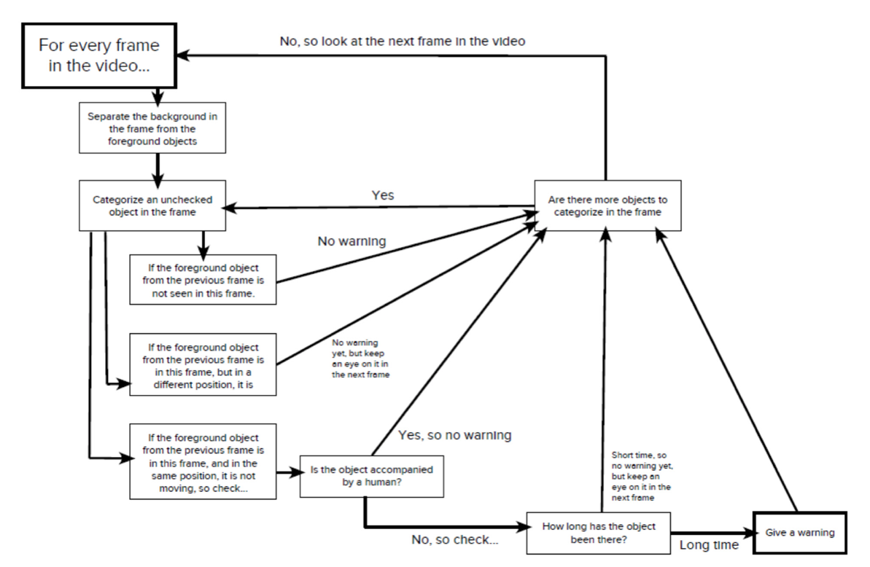



=> According to the above algorithm graph.

4/ Since computer-based solutions require questions that are specific and quantifiable, which one of the following question is **most** appropriate for a computer-based solution? How many people have entered the airport in the past two hours

=> The question is specific (people that have entered the airport in the past two hours) and quantifiable (How many people)

5/ What is an algorithm? A process or defined set of rules used by a computer for solving an identified problem.

=> Algorithm is a process or defined set of rules used by a computer to be executed that lead to the problem solving

1. Week 3 – Case-study Epidemiology

Summary case-study: Solving complex problems in epidemiology related to flu prevention

1/ In the epidemiology case study, we constructed the following algorithm 

S: number of people susceptible to infection

b: the rate of infection

l: number of people infected

r: recovery rate

R: number of people recovered from infection

The rate of infection b would decrease, which would result in less infected people l

=> b >< l , r >< R [ >< (ratio) <> ( inverse ratio ) ]

2/ In the epidemiology case study, the *SIR* model accounted for the number of people susceptible to infection, the rate of infection, the number of people infected, the rate of recovery, and the number of people who recovered from the infection. If we wanted to create a more accurate model for predicting the spread of the flu, what information would be **most** relevant for this problem? The migration patterns of infected people

=> This patterns help people to predict locations where the flu might spread

3/ Predicting the number of people who will become infected with the seasonal flu can be a complex problem. In computational thinking terms, describing this complex problem in such a way so that it can be solved by a computer is known as Problem Identification

=> This process determines the problem is solvable to a computer.

4/ In the epidemiology case study, the *SIR* model utilized the following information: the number of people susceptible to infection (*S*), the rate of infection (*b*), the number of people infected (*I*), the recovery rate (*r*), and the number of people who recovered from infection (*R*). This process of focusing on relevant information and ignoring less relevant information represents what computational thinking technique? Abstraction

=> Abstraction is a concept of remove not important information for solving the main problem.

5/ In the epidemiology case study, we expanded on the original SIR model by adding information about vaccinations. The expanded model looked like this

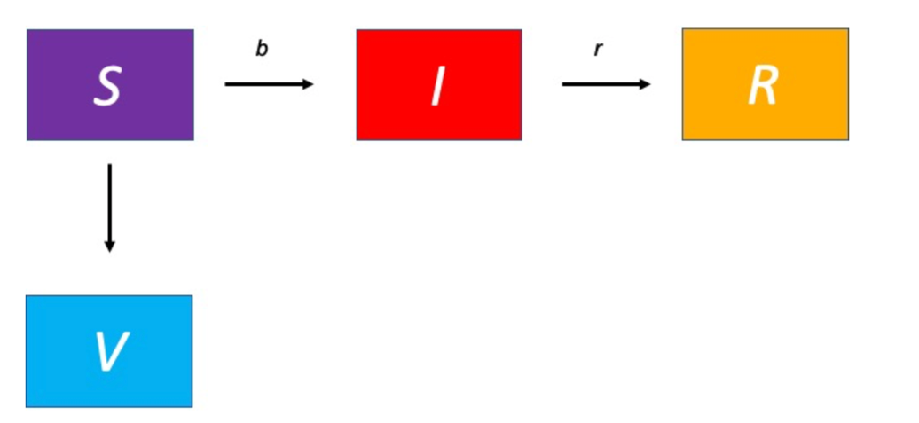

V: number of vaccinations (V) decreases the number of. People who are susceptible to infection (S)

Using this algorithm, what will happen to the number of people recovered ( R ) at the end of an epidemic if we increase V at the beginning The number of people recovered (R) will decrease

=> Increasing the number of people vaccinated before an outbreak occe`urs means that fewer people will become infected, so the total number of people who recover will decrease.

1. Week 4 – Human Trafficking

Summary case-study: Solving complex problems in Human Trafficking

1/During the decomposition process, you will need to break down the “big

problem” into smaller “sub-problems.” In your own words, explain how the large issue of human trafficking was decomposed into smaller “sub-problems.”

=> Human trafficking was decomposed a variety of different ways. Human

trafficking was decomposed by focusing on different scales (global, national,

regional). It was also decomposed by focusing on different aspects of human

trafficking, such as recruitment, transportation, and forced labor.

2/ One way researchers are helping combat human trafficking is by analyzing the frequency of certain words posted on social media at a large event. For instance, the word “escort” commonly appears in social media posts advertising trafficked people for sexual exploitation. However, searching for all occurrences of “escort” yields many unwanted results—for example, when the posts are about a “Ford Escort” (car model) or a “police escort.” So it’s helpful to also eliminate results that contain the words “Ford” or “police.” Eliminating these results is an example of: Abstraction

3/In the human trafficking case-study, "purchase" and "escort" were considered suspicious words in social media advertisements. If you were designing an algorithm that flagged suspicious human trafficking advertisements, what other words or phrases might be flagged as suspicious?

=>Social media has been used by traffickers to recruit victims, to proliferate their

trafficking operations, and to control victims through restricting their social

media access, impersonating the victim, or spreading lies and rumors online.

4/ When designing an algorithm that flags suspicious human trafficking

advertisements, you should be identifying questions that are specific,

quantifiable, and relevant to your problem. Which question is specific,

quantifiable, and relevant to human trafficking? Which social media advertisements contain the words "purchase" and "escort"?

5/ When you are testing a new algorithm, it is a good idea to test it in a simplified, controlled environment. If you were designing a new algorithm that flags suspicious social media advertisements, how might you begin testing this algorithm?

=> Social media algorithms are a way of sorting posts in a users’ feed based on relevancy instead of publish time. Social networks prioritize which content a user sees in their feed first by the likelihood that they’ll actually want to see it. Before the switch to algorithms, most social media feeds displayed posts inreverse chronological order. In short, the newest posts from accounts a user followed showed up first.